RETRIEVING DISHES DATA (Important to Understand)
- This is the workflow (Clean Architecture Top to Down Flow)
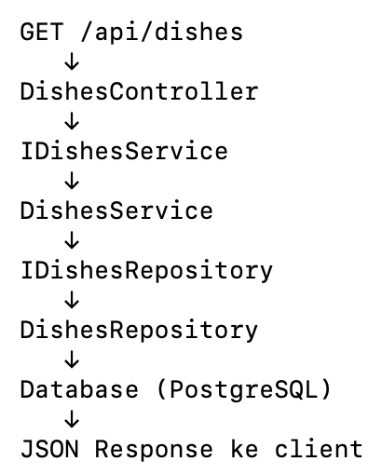
- Create DishesController
- Create IDishesService.cs in the Application module (Dishes/ DishesService.cs)
- Create DishesService.cs in the same folder
- Create IDishesRepository.cs in the Domain module (Repositories/IDishesRepositoy.cs)
- Create DishesRepository.cs in the Infrastructure module (Repositories/DishesRepositoy.cs)
- Edit the ServiceCollectionExtensions.cs in the Application module
  - This file was created already during Restaurants Api Setup
  - This file also needed because it is a centralized place to register your application services for Dependency Injection (DI)
  - Just need to AddScoped for our new services
- Edit the ServiceCollectionExtensions.cs in the Infrastructure module
  - This file exists to register infrastructure-specific services in the DI container
- Check our program.cs already have:
  - builder.Services.AddControllers()
  - builder.Services.AddApplication()
  - app.MapControllers()

STEP BY STEP TUTORIAL

- Create DishesController
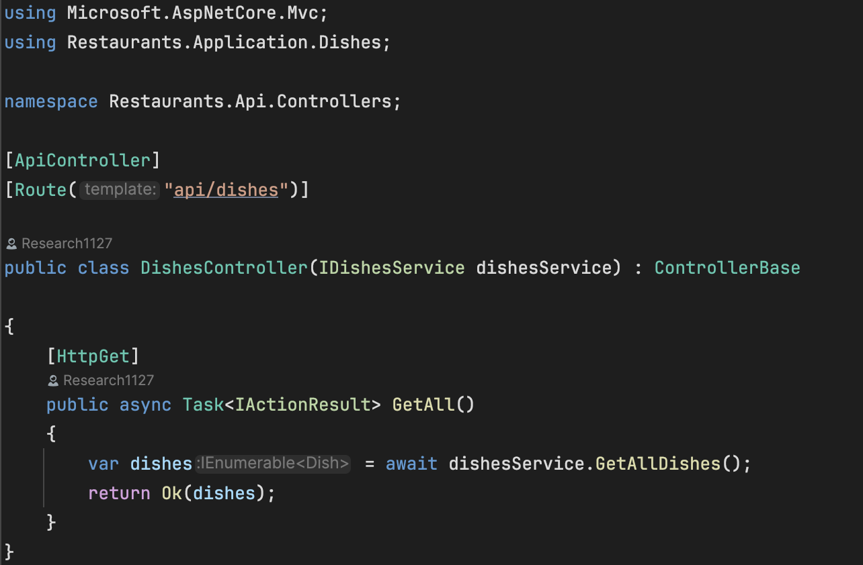
- Create IDishesService.cs in the Application module (Dishes/ DishesService.cs)
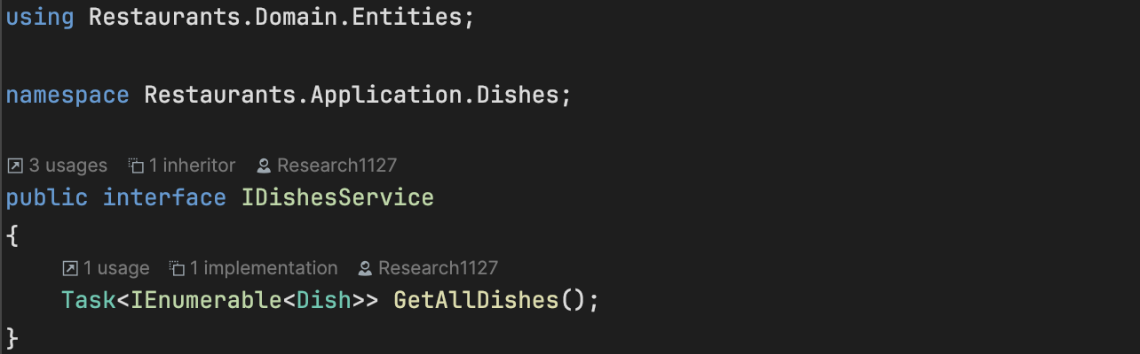

- Create DishesService.cs in the same folder
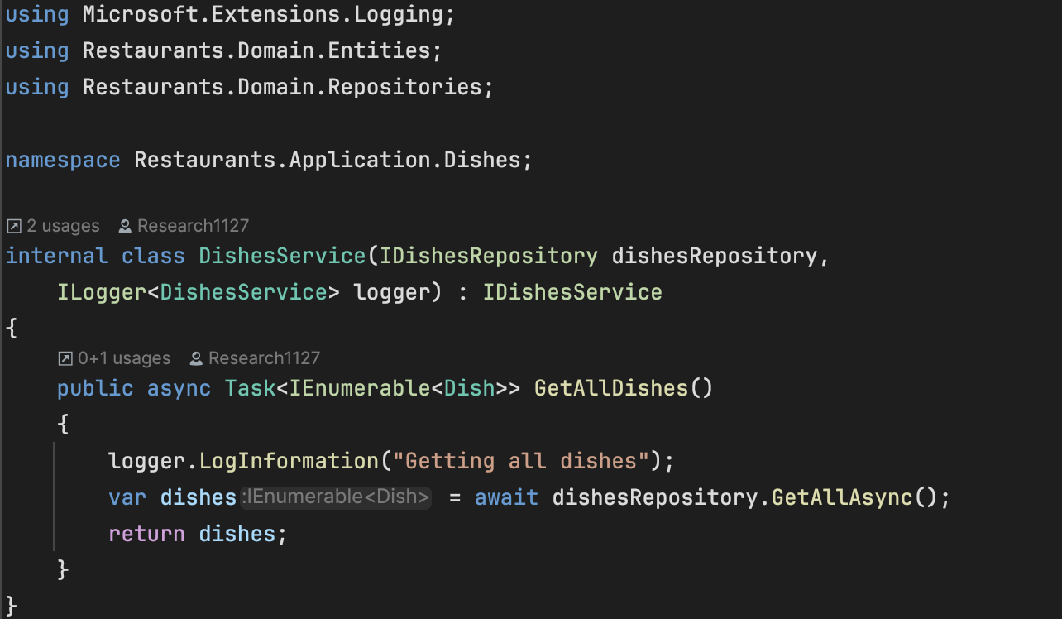
- Create IDishesRepository.cs in the Domain module (Repositories/IDishesRepositoy.cs)
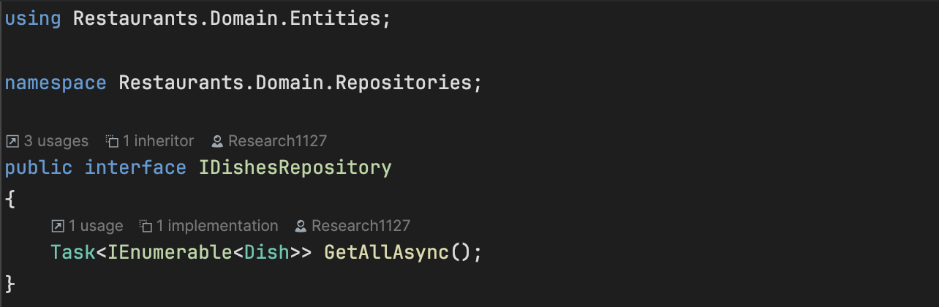

- Create DishesRepository.cs in the Infrastructure module (Repositories/DishesRepositoy.cs)
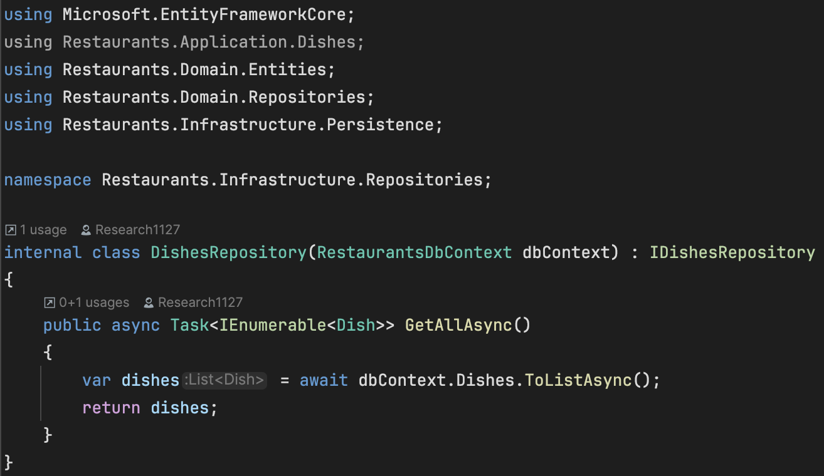
- Edit the ServiceCollectionExtensions.cs in the Application module
  - This file was created already during Restaurants Api Setup
  - This file also needed because it is a centralized place to register your application services for Dependency Injection (DI)
  - Just need to AddScoped for our new services
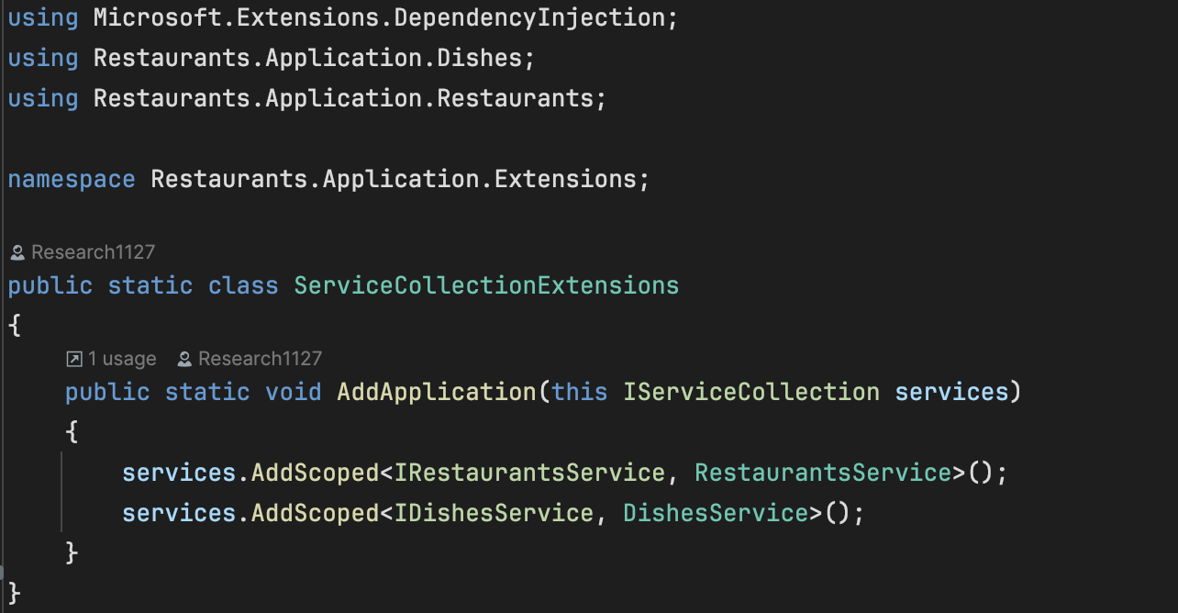
- Edit the ServiceCollectionExtensions.cs in the Infrastructure module
  - This file exists to register infrastructure-specific services in the DI container
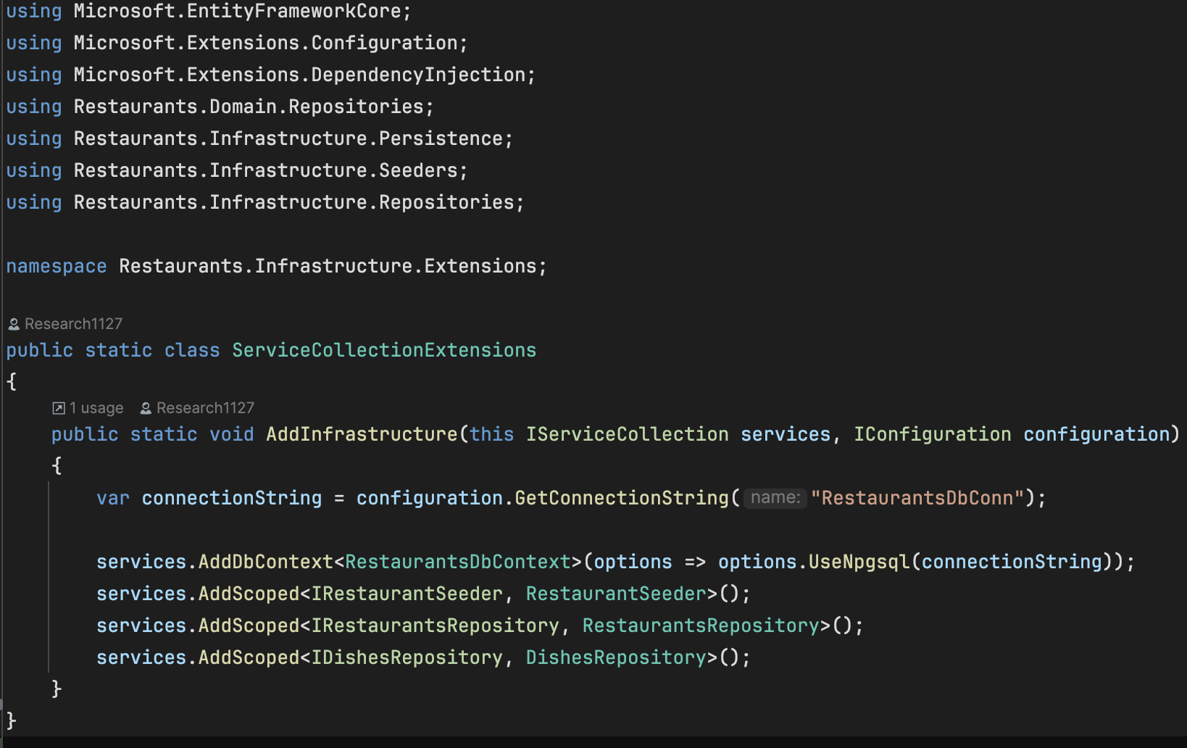

- Check our program.cs already have:
  - builder.Services.AddControllers()
  - builder.Services.AddApplication()
  - app.MapControllers()
